Project Design Phase-II
Data Flow Diagram & User Stories
Date: 29.09.2026
Team ID: __________
Project Name: LegalEase
Maximum Marks: 4 Marks

Data Flow Diagrams
A Data Flow Diagram (DFD) is a graphical representation of how data flows through the LegalEase system. It shows how users provide information, how the system processes the information, where data is stored, and how the processed information is returned to users.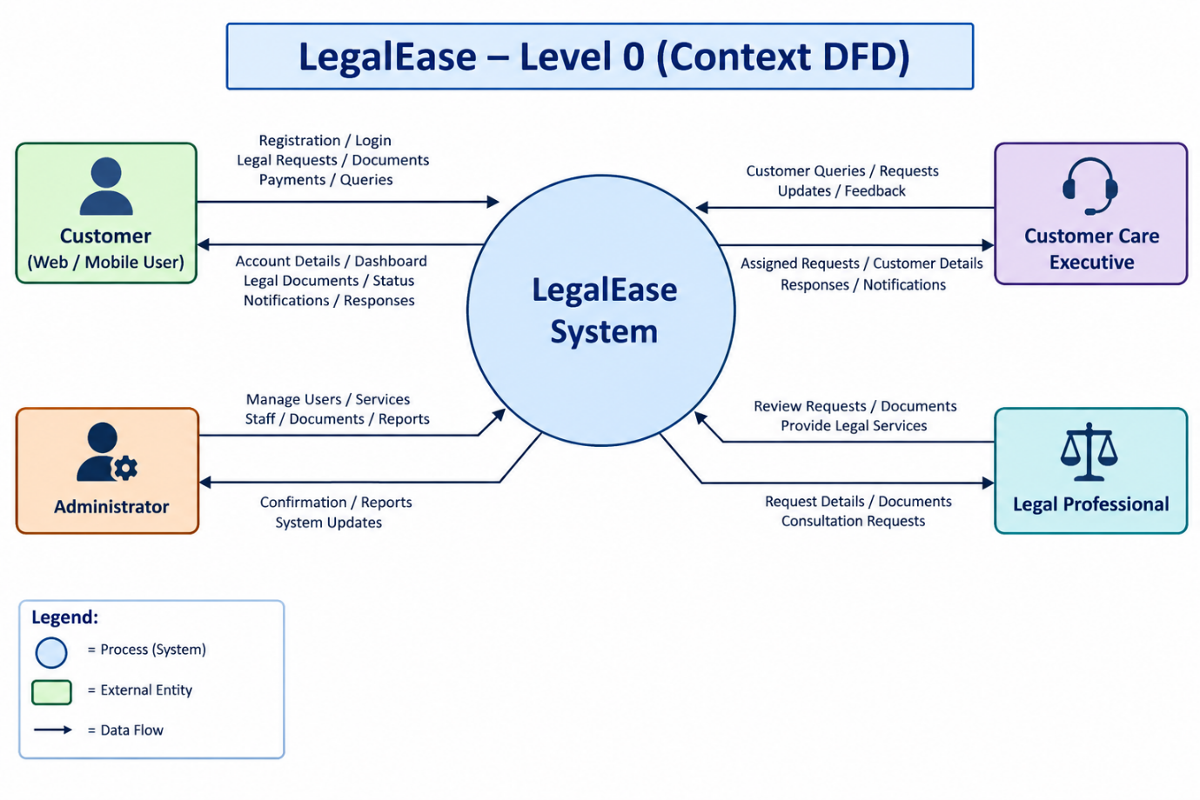

User Stories
The following user stories describe the functional requirements of the LegalEase application.
User Type | Functional Requirement (Epic) | User Story Number | User Story / Task | Acceptance Criteria | Priority | Release
Customer (Web/Mobile User) | Registration | USN-1 | As a user, I can register for LegalEase using my name, email, mobile number and password. | I can successfully create an account and access my dashboard. | High | Sprint-1
Customer (Web/Mobile User) | Registration | USN-2 | As a user, I can verify my email/mobile number after registration. | I receive a verification message and can verify my account. | High | Sprint-1
Customer (Web/Mobile User) | Login | USN-3 | As a user, I can log into LegalEase using my registered email/mobile number and password. | I can securely access my dashboard after successful login. | High | Sprint-1
Customer (Web/Mobile User) | Login | USN-4 | As a user, I can reset my password if I forget it. | I can receive a reset link/OTP and create a new password. | High | Sprint-1
Customer (Web/Mobile User) | Dashboard | USN-5 | As a user, I can view my LegalEase dashboard. | I can view my requests, documents, appointments and notifications. | High | Sprint-1
Customer (Web/Mobile User) | Legal Services | USN-6 | As a user, I can browse available legal services. | I can view different legal services and their details. | High | Sprint-1
Customer (Web/Mobile User) | Legal Request | USN-7 | As a user, I can submit a legal request by providing the required information. | My request is successfully submitted and a request ID is generated. | High | Sprint-1
Customer (Web/Mobile User) | Document Upload | USN-8 | As a user, I can upload documents related to my legal request. | Supported documents can be uploaded and viewed securely. | High | Sprint-2
Customer (Web/Mobile User) | Document Management | USN-9 | As a user, I can view and download my legal documents. | I can securely access documents associated with my account. | High | Sprint-2
Customer (Web/Mobile User) | Lawyer/Expert Consultation | USN-10 | As a user, I can request a consultation with a legal professional. | I can select an available professional and submit a consultation request. | High | Sprint-2
Customer (Web/Mobile User) | Appointment | USN-11 | As a user, I can schedule a legal consultation appointment. | I can select an available date/time and receive confirmation. | Medium | Sprint-2
Customer (Web/Mobile User) | Notifications | USN-12 | As a user, I can receive notifications about my legal requests and appointments. | I receive notifications when the status or appointment changes. | Medium | Sprint-2
Customer (Web/Mobile User) | Payment | USN-13 | As a user, I can make online payments for applicable legal services. | Payment is processed successfully and a receipt is generated. | High | Sprint-2
Customer (Web/Mobile User) | Request Tracking | USN-14 | As a user, I can track the status of my legal request. | I can view whether my request is pending, processing, completed or closed. | High | Sprint-2
Customer (Web/Mobile User) | Feedback | USN-15 | As a user, I can provide feedback after receiving a legal service. | I can submit a rating and feedback successfully. | Low | Sprint-3
Customer Care Executive | Customer Support | USN-16 | As a customer care executive, I can view customer requests and queries. | I can access assigned customer requests and their details. | High | Sprint-2
Customer Care Executive | Query Management | USN-17 | As a customer care executive, I can respond to customer queries. | Customers can receive my response through the application. | High | Sprint-2
Customer Care Executive | Request Management | USN-18 | As a customer care executive, I can update the status of customer requests. | The updated status is visible to the customer. | High | Sprint-2
Customer Care Executive | Appointment Management | USN-19 | As a customer care executive, I can manage customer appointments. | I can confirm, reschedule or cancel appointments. | Medium | Sprint-3
Administrator | User Management | USN-20 | As an administrator, I can manage customer accounts. | I can view, activate, deactivate or manage user accounts. | High | Sprint-1
Administrator | Employee Management | USN-21 | As an administrator, I can manage customer care executives and legal professionals. | I can add, update and deactivate staff accounts. | High | Sprint-2
Administrator | Service Management | USN-22 | As an administrator, I can add, edit and remove legal services. | Updated services are reflected in the customer application. | High | Sprint-2
Administrator | Document Management | USN-23 | As an administrator, I can manage legal documents and templates. | I can add, update and remove authorized documents/templates. | Medium | Sprint-3
Administrator | Payment Management | USN-24 | As an administrator, I can view and manage payment transactions. | I can view transaction details and payment status. | Medium | Sprint-3
Administrator | Reports | USN-25 | As an administrator, I can generate reports about users, requests and services. | Reports can be generated and viewed based on selected criteria. | Medium | Sprint-3
Administrator | Security | USN-26 | As an administrator, I can monitor system activity and manage access permissions. | Only authorized users can access restricted functions. | High | Sprint-3

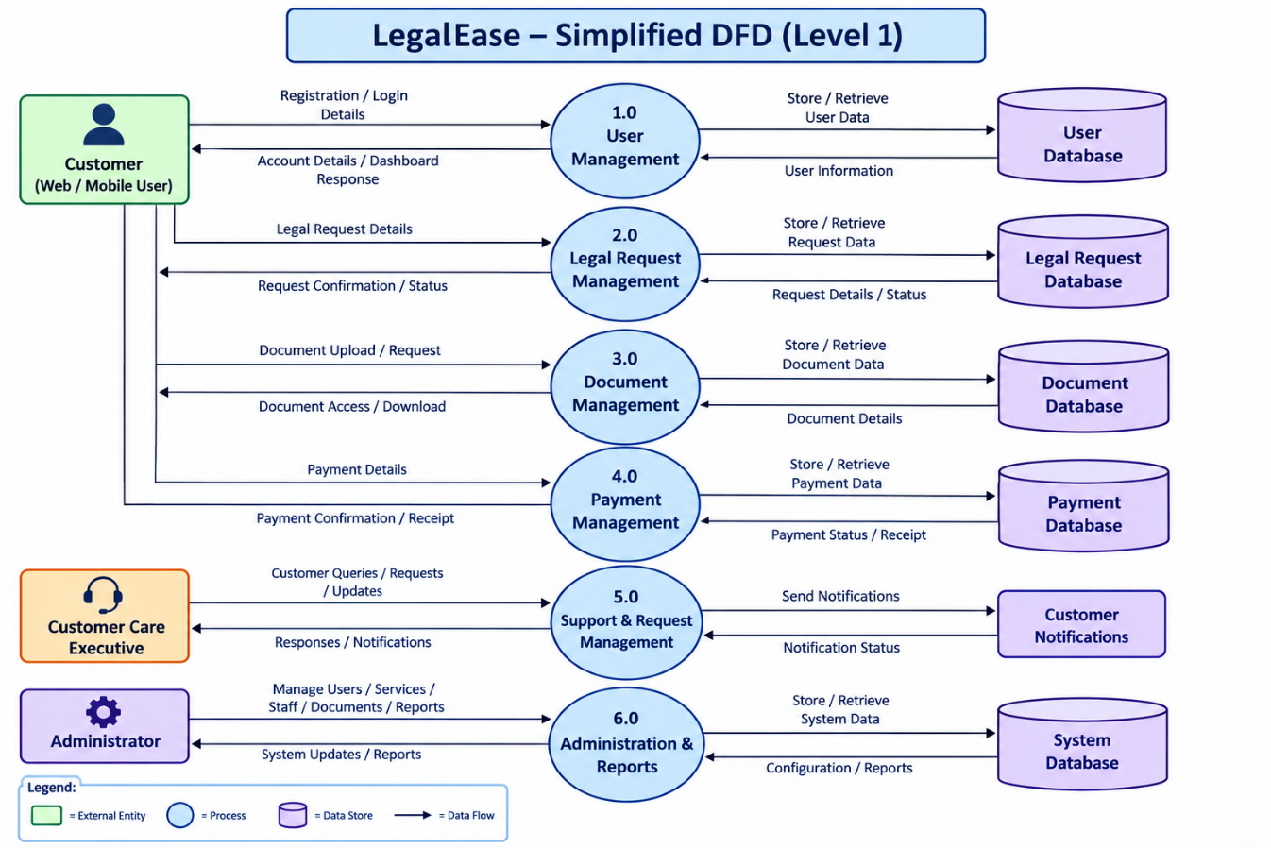Main Actors in LegalEase
- Customer (Web/Mobile User) – Registers, logs in, requests legal services, uploads documents, books consultations, makes payments and tracks requests.
- Customer Care Executive – Handles customer queries, manages requests and appointments, and communicates with customers.
- Legal Professional – Reviews legal requests/documents and provides legal consultation or services.
- Administrator – Manages users, services, staff, documents, payments, reports and system access.

